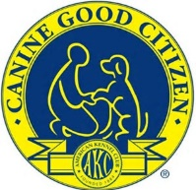
Earn the Canine Good Citizen (CGC) or a Community Canine (CGCA) title at the shows. Testing will be held beginning at 3 pm, Wednesday, July 31st. Community Canine will be conducted first followed by the CGC test. All registrants (both CGC, CGCA & Trick Dog) must report to the Ring at 3:00 pm. The Evaluator will not wait for late entries. (Evaluating Ring TBD)
For test requirements visit https://www.akc.org/products-services/training-programs/canine-good-citizen/.
Cost of the test is $15, payable at the time of testing. Limit: 10 dogs for each level. If spaces are not filled prior to July 31st, we will take entries at the test. Those passing the test will be awarded a ribbon.
Evaluator is Deb Straw, Prize ECs. For additional information and/or to sign up, contact Deb Straw at debstraw@aol.com.

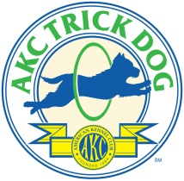
Earn an AKC Trick Dog Title at the shows. Testing will be held immediately following the CGC Testing, Wednesday, July 31st. All registrants (both CGC, CGCA & Trick Dog) must report to the Ring at 3:00 pm. The Evaluator will not wait for late entries. (Evaluating Ring TBD)
For test requirements visit https://www.akc.org/sports/trick-dog/. Cost of the test is $15, payable at the time of testing. Limit: 10 dogs. If spaces are not filled prior to July 31st, we will take entries at the test.
The following props will be available on site: Walker, Cardboard Box, Low Platform, Bar Jump, Crate. The Exhibitor will be responsible for any other props they may need.
Evaluator is Deb Straw, Prize ECs. For additional information and/or to sign up, contact Deb Straw at debstraw@aol.com.

